Problem No:
Problem Statement:

Codes:
#include <bits/stdc++.h>
using namespace std;

int par[10000];
int findrep(int r)
{
if (par[r] == r)
return r;
return par[r] = findrep(par[r]);
}

void Union(int a, int b)
{
int u = findrep(a);
int v = findrep(b);
if (u == v)
cout << "They are already in the same set" << endl;
else
{
par[u] = v;
}
}
vector<pair<int, pair<int, int>>> edge;

int main()
{
int n, e, u, v, c;
cin >> n >> e;
for (int i = 1; i <= n; i++)
{
par[i] = i;
}
for (int k = 0; k < e; k++)
{
cin >> u >> v >> c;
// edge.push_back({c, {u, v}});
edge.push_back(make_pair(c, make_pair(u, v)));
}
sort(edge.begin(), edge.end());
int mst = 0;
for (int j = 0; j < edge.size(); j++)
{
int cst = edge[j].first;

int p = edge[j].second.first;
int q = edge[j].second.second;
if (findrep(p) != findrep(q))
{
Union(p, q);

mst += cst;
cout << p << "->" << q << " with cost " << cst << endl;
}
}
cout << mst << endl;
}

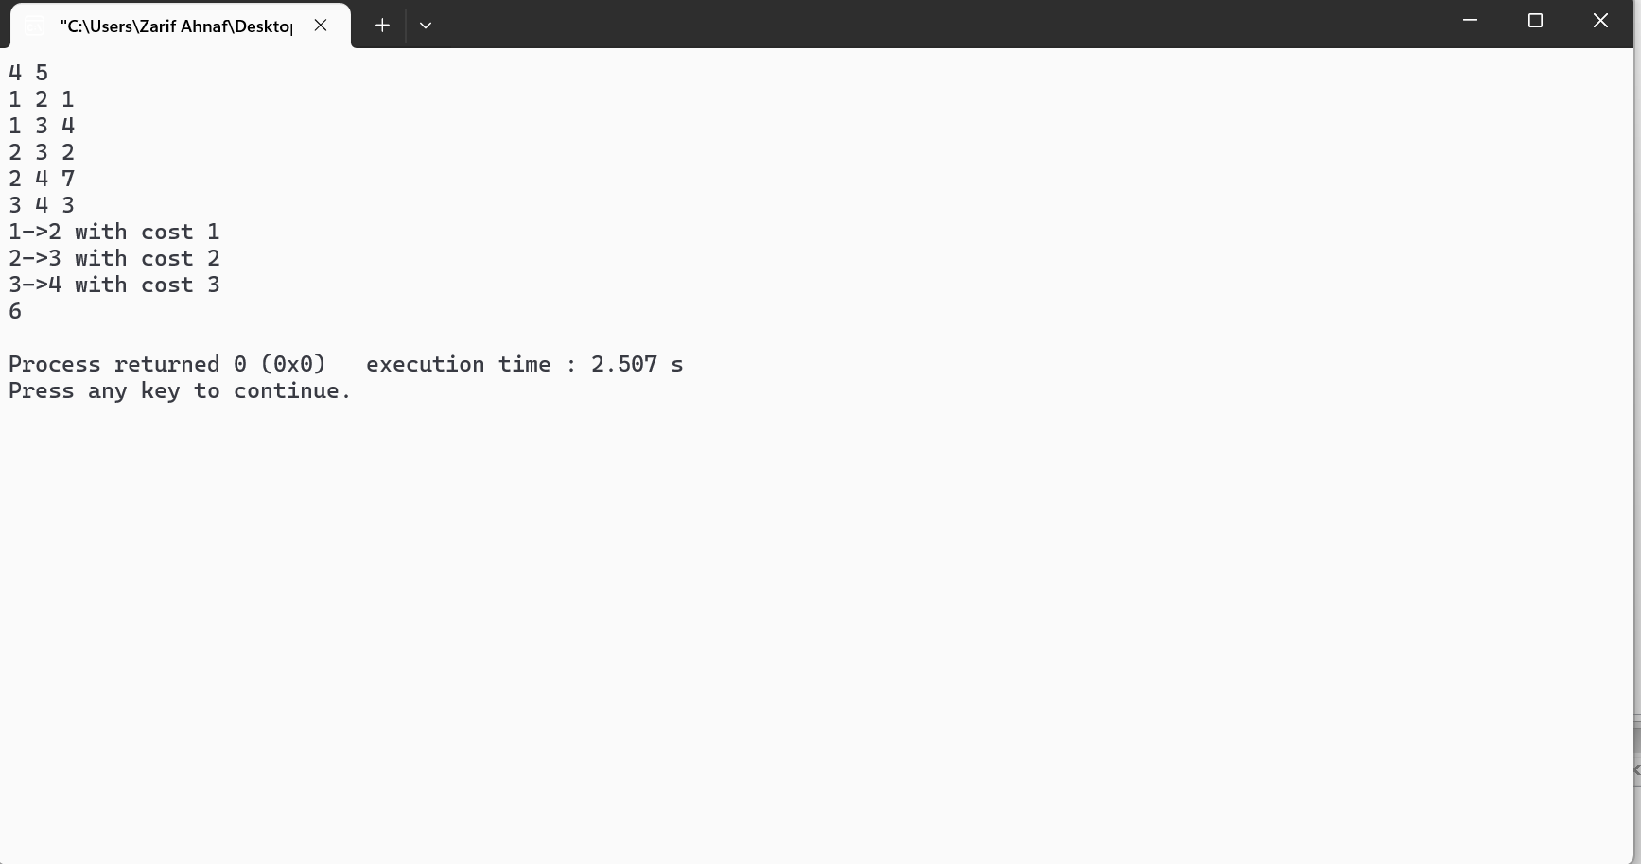
Output:

